Machine learning is in many ways the intersection of two disciplines - data science and software engineering. The goal of machine learning is to use data to create a predictive model that can be incorporated into a software application or service. To achieve this goal requires collaboration between data scientists who explore and prepare the data before using it to train a machine learning model, and software developers who integrate the models into applications where they're used to predict new data values (a process known as inferencing).

Machine learning has its origins in statistics and mathematical modeling of data. The fundamental idea of machine learning is to use data from past observations to predict unknown outcomes or values. For example:

Because machine learning is based on mathematics and statistics, it's common to think about machine learning models in mathematical terms. Fundamentally, a machine learning model is a software application that encapsulates a function to calculate an output value based on one or more input values. The process of defining that function is known as training. After the function has been defined, you can use it to predict new values in a process called inferencing.

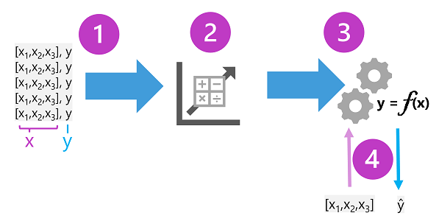

The training data consists of past observations. In most cases, the observations include the observed attributes or features of the thing being observed, and the known value of the thing you want to train a model to predict (known as the label).
In mathematical terms, you'll often see the features referred to using the shorthand variable name x, and the label referred to as y. Usually, an observation consists of multiple feature values, so x is actually a vector (an array with multiple values), like this: [x₁,x₂,x₃,...].
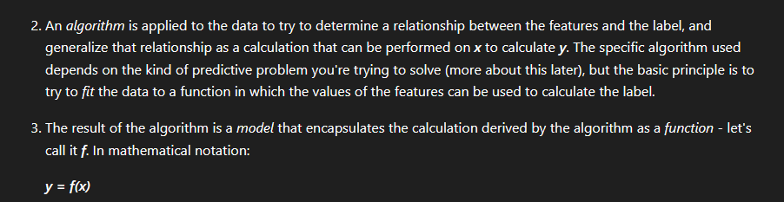
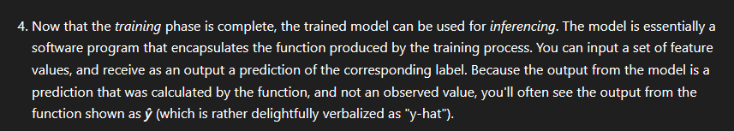

https://learn.microsoft.com/en-us/training/modules/fundamentals-machine-learning/3-types-of-machine-learning?pivots=text

